

QUANTITATIVE SCIENCES DEPARTMENT |  | 
Course: A2MAA
Topic Title: Skills Test 3
Student Name:_____________________________________ | Date: __________2015
Special Instructions: No calculator or notes | Time Allowed: 20 minutes
 | Marks: / 20

Question 1 [4 marks]
Construct a frequency table for the following scores.

77 80 76 75 80 75 76 80 78 78

Question 2 [5 marks]
Organise the data below into a grouped frequency distribution table using the
class intervals 50–59, 60–69, ...

79 | 81 | 84 | 84 | 60 | 87 | 51 | 59 | 82 | 59
58 | 62 | 81 | 65 | 52 | 60 | 85 | 68 | 88 | 82
73 | 65 | 88 | 70 | 80 | 83 | 51 | 52 | 50 | 69
76 | 51 | 53 | 75 | 56 | 89 | 88 | 58 | 76 | 67
74 | 59 | 77 | 54 | 65 | 76 | 54 | 73 | 67 | 70

Question 3 [6 marks]

Represent the following frequency table as a histogram.
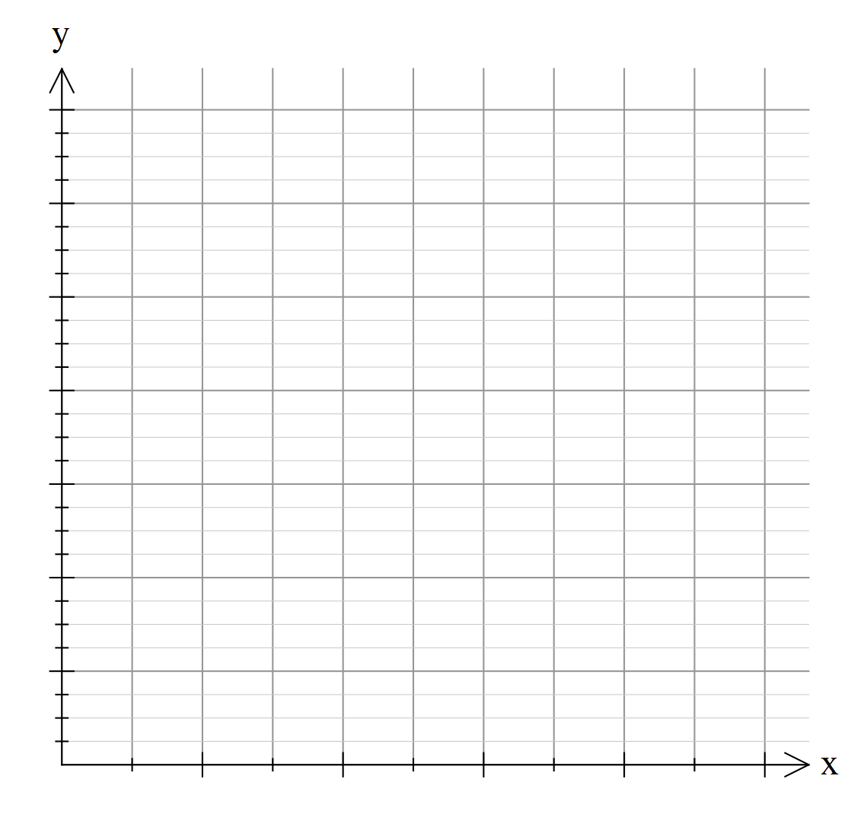

Score | Frequency
1 | 6
2 | 10
3 | 11
4 | 10
5 | 12
6 | 0
7 | 4
8 | 0
9 | 1

Question 4 [6 marks]

Consider the data below:

32, 51, 63, 17, 44, 65, 69, 68, 73, 8, 74, 72, 35, 63, 52, 26, 56, 72

Use the data to constuct a stem and leaf plot

